

ASSET VERIFICATION AND RECORDING TOOL KIT


Plot 31, Bukoto Street
P.O Box 7657, Kampala, Uganda
+256 (0) 39 2000216/0772525235
email: cpa@cpa.ug

www.cpa.com

August to September 2026

VERIFICATION DETAILS

NAME OF THE REGION: | GREATER MASAKA
SUB-REGION: | SSEMBABULE DISTRICT
Name of Local Government
VERIFIER PARTICULARS
Full name | NASSALI VICTORIA K/NANTUME PENNINAH
Contact/ email and Telephone | 0760394649/0704321431
Supervisor/ Sub team leader
Name | KALYOWA LAWRENCE
Contact | 0774106047
Date of submission

HEALTH CENTRES
INFORMANT INTERVIEW/DISCUSSION GUIDE (INCHARGE OR RESPONSIBLE PERSON)

Name of Health Centre: BUSHEKA HEALTH CENTRE III

1a | Does the Facility have a record of all assets provided under UgIFT.  (Obtain a record and verify if it has the costs and numbers supplied | Yes
1b | If Not ask how many were supplied and when.

2 | How does this facility Maintain (repair/service/replace) the assets provided under Ugift

They get funds from the government.

3 | Does the facility take regular record about functionality/ or breakdown of the assets provided?

Yes and it is one of the best health centers in the Ssembabule district.

4 | How has the UgIFT support helped in service delivery in the area, any issues, challenges and any recommendations for better program implementation.

Challenges
- They don’t have enough staff to work with
- They get little salary

Recommendations
- More staffs are needed
- Increment of their salary.

PROCEED TO VERIFICATION AFTER THIS DISCUSSION

Health centre checklist

NAME OF LG: SSEMBABULE DISTRICT NAME OF HEALTH FACILITY: BUSHEKA HEALTH LOCAL DISTRICT

Equipment/ Item | Department | Asset Number | Item  Description | Life in Months | Tag Number ( engrave no.) | Date Of Purchase | Date Placed In Service | Recoverable cost | Cost | Acc Dep Cost | Net Book Value | Ytd Deprn | Equipment status | Remarks
B.P. Machine, Digital | Health |  | Received 2 white in colour |  |  | 2024/25 | 2024/25 |  |  |  |  |  | Good | Functional
B.P. Machine (Aneroid wall mounted) | Health |  | Received 2 white in colour |  |  | 2024/25 | 2024/25 |  |  |  |  |  | Good | Functional
Autoclave 20 Liters.,Duo Operated
Bowl, Kick | Health |  | Received 1 stainless steel |  |  | 2024/25 | 2024/25 |  |  |  |  |  | Good | Functional
Bowl Stand | Health |  | Received 2 stainless steel |  |  | 2024/25 | 2024/25 |  |  |  |  |  | Good | Functional
Counting chamber Neubauer- Improved | Health |  | Received 2 white in colour |  |  | 2024/25 | 2024/25 |  |  |  |  |  | Good | Functional
Cupboard Steel, Lockable | Health |  | Received 2 grey in colour |  | Not engraved | 2024/25 | 2024/25 |  |  |  |  |  | Good | Functional
Drip Stand | Health |  | Received 8 white in colour |  | Not engraved | 2024/25 | 2024/25 |  |  |  |  |  | Good | Functional
ESR Stand | Health |  | Received 1 with sedimentation tube |  | Not engraved | 2024/25 | 2024/25 |  |  |  |  |  | Good | Functional
Examination Couch | Health |  | They received 2 examination couch metallic |  | Not engraved | 2024/25 | 2024/25 |  |  |  |  |  | Good | Functional
Examination light,LED | Health |  | They received 2 in silver colour |  | Not engraved | 2024/25 | 2024/25 |  |  |  |  |  | Good | Functional
Glucometer | Health |  | They received 2 white and yellow |  | Not engraved | 2024/25 | 2024/25 |  |  |  |  |  | Good | Functional
Haemoglobin Meter, Digital | Health |  | Received 2 but not seen |  |  | 2024/25 | 2024/25 |  |  |  |  |  | Good | Functional
Height Meter | Health |  | They received 1 but not seen |  |  | 2024/25 | 2024/25 |  |  |  |  |  | Good | Functional
Instrument Trolley | Health |  | Received 2 silver and black in colour |  | Not engraved | 2024/25 | 2024/25 |  |  |  |  |  | Good | Functional
Microscope Binocular | Health |  | Received 1 white in colour |  | Not engraved | 2024/25 | 2024/25 |  |  |  |  |  | Good | Functional
Otoscope | Health |  | They received bt not seen |  |  | 2024/25 | 2024/25 |  |  |  |  |  | Good | Functional
Patient Screen | Health |  | They received 4 metallic in blue colour |  | Not engraved | 2024/25 | 2024/25 |  |  |  |  |  | Good | Functional
Patient Trolley | Health |  | It was 1 in silver and black colour |  | Not engraved | 2024/25 | 2024/25 |  |  |  |  |  | Good | Functional
Refrigerator, Basic | Health |  | It was 1 in grey colour |  | Not engraved | 2024/25 | 2024/25 |  |  |  |  |  | Good | Functional
Stethoscope | Health |  | They were 4 but not verified |  |  | 2024/25 | 2024/25 |  |  |  |  |  | Good | Functional
Stop Watch | Health |  | They were 2 but not verified |  |  | 2024/25 | 2024/25 |  |  |  |  |  | Good | Functional
Stretcher | Health |  | It was 1 with a black mattress |  | Not engraved | 2024/25 | 2024/25 |  |  |  |  |  | Good | Functional
Stove, Gas | Health |  | It was 1 6kilos stabex |  | Not engraved | 2024/25 | 2024/25 |  |  |  |  |  | Good | Functional
Weighing Scale with Height Meter, Adult | Health |  | They were 2 with a heightmeter |  | Not engraved | 2024/25 | 2024/25 |  |  |  |  |  | Good | Functional
Weighing Scale, Infant | Health |  |  |  |  | 2024/25 | 2024/25 |  |  |  |  |  | Good | Functional
Weighing Scale, Toddler
Wheel Chair
Audio Visual Equipment
Medical Waste Bin | Health |  | They received 6 stainless wastebins |  | Not engraved | 2024/25 | 2024/25 |  |  |  |  |  | Good | Functional
Wall Clock | Health |  | They were 4 round and white |  | Not engraved | 2024/25 | 2024/25 |  |  |  |  |  | Good | Functional
Diagnostic Equipment Set for MCH | Health |  | They were 2 but not verified |  |  | 2024/25 | 2024/25 |  |  |  |  |  | Good | Functional
Diagnostic Equipment Set for OPD | Health |  | They were 2 but not verified |  |  | 2024/25 | 2024/25 |  |  |  |  |  | Good | Functional
Glassware Set, Laboratory, Basic | Health |  | They were 2 colorless and broken |  | Not engraved | 2024/25 | 2024/25 |  |  |  |  |  | Good | Functional
Hollow Ware Set, Treatment
Instrument Set, Dressing | Health |  | They were 2 consists of 2 scissors |  | Not engraved | 2024/25 | 2024/25 |  |  |  |  |  | Good | Functional
Instrument Set, Basic ENT | Health |  | They received 3 but not verified |  |  | 2024/25 | 2024/25 |  |  |  |  |  | Good | Functional
Instrument Set, Suture
Pulse Oximeter, Hand held | Health |  | They received 2 but not verified |  |  | 2024/25 | 2024/25 |  |  |  |  |  | Good | Functional
Bed, Adult Patient with Mattress | Health |  | They received 10 beds with black mattresses |  | Not engraved | 2024/25 | 2024/25 |  |  |  |  |  | Good | Functional
Bed, Pediatric Patient, With Mattress | Health |  | They received 5 with black mattresses |  | Not engraved | 2024/25 | 2024/25 |  |  |  |  |  | Good | Functional
Bedside Locker |  |  | They received metallic bed lockers with steel |  | Not engraved
Cupboard, Instrument | Health |  | They received 1 but not verified |  |  | 2024/25 | 2024/25 |  |  |  |  |  | Good | Functional
Delivery Bed, Hydraulic Manual | Health |  | They received 1 hydraulic |  | Not engraved | 2024/25 | 2024/25 |  |  |  |  |  | Good | Functional
Oxygen Therapy Apparatus, Mininum 45L cylinder | Health |  | They received 2 with 49.8 liters with 2 modifiers |  | Not engraved | 2024/25 | 2024/25 |  |  |  |  |  | Good | Functional
Resuscitator Manual, Infant, with all Mask sizes | Health |  | They received 2 when all are manual |  | Not engraved | 2024/25 | 2024/25 |  |  |  |  |  | Good | Functional
Resuscitator Manual, Adult, with all mask sizes | Health |  | They received 2 when manual |  | Not engraved | 2024/25 | 2024/25 |  |  |  |  |  | Good | Functional
Suction Apparatus, (Electric) | Health |  | It was 1 apparatus |  | Not engraved | 2024/25 | 2024/25 |  |  |  |  |  | Good | Functional
Nebulizer, Ultrasonic | Health |  | They received 1 ultrasonic |  | Not engraved | 2024/25 | 2024/25 |  |  |  |  |  | Good | Functional
Oxygen Concentrator, Duo Flow | Health |  | They received 4 oxygen concentrators green in colour |  | Not engraved | 2024/25 | 2024/25 |  |  |  |  |  | Good | Functional
Bench | Health |  | They received 4 metallic and vanished shade |  | Not engraved | 2024/25 | 2024/25 |  |  |  |  |  | Good | Functional
Disinfection Buckets | Health |  | Received 6 normal buckets |  | Not engraved | 2024/25 | 2024/25 |  |  |  |  |  | Good | Functional
Baby Cot | Health |  | Received 5 but not verified |  |  | 2024/25 | 2024/25 |  |  |  |  |  | Good | Functional
Diagnostic Equipment Set for Ward | Health |  | Received 3 but not verified |  |  | 2024/25 | 2024/25 |  |  |  |  |  | Good | Functional
Hollow Ware Set, Ward | Health |  | They received 3 but not verified |  |  | 2024/25 | 2024/25 |  |  |  |  |  | Good | Functional
Instrument Set, Delivery | Health |  | They received 4 but not verified |  |  | 2024/25 | 2024/25 |  |  |  |  |  | Good | Functional
Instrument Set, Stitch Removing | Health |  | They received 4 but not verified |  |  | 2024/25 | 2024/25 |  |  |  |  |  | Good | Functional
MVA Kit | Health |  | Received 4 but not verified |  |  | 2024/25 | 2024/25 |  |  |  |  |  | Good | Functional
Stool, Laboratory | Health |  | It was 1 black in colour |  |  | 2024/25 | 2024/25 |  |  |  |  |  | Good | Functional
Penguin Sucker | Health |  | They were 3 but not verified |  |  | 2024/25 | 2024/25 |  |  |  |  |  | Good | Functional
Fetoscope, Dopplar | Health |  | They were 2 but not verified |  |  | 2024/25 | 2024/25 |  |  |  |  |  | Good | Functional
Bubble CPAP
Centrifuge (Electric) | Health |  | They were 2 but not verified |  |  | 2024/25 | 2024/25 |  |  |  |  |  | Good | Functional
Kangaroo Mother Care Chair | Health |  | It was 1 but not seen |  |  | 2024/25 | 2024/25 |  |  |  |  |  | Good | Functional
Radiant Infant Warmer
Haemoglobin Meter, Sahli
Delivery Bed |  |  | It was 1 with a mattress |  | Not engraved
Examination light
Instrument set, ENT Basic for HCIII
Bag Valve mask (Ambu Bag), Neonatal |  |  | Bagvalve mask not verified
Incubator
Office Chair | Health |  | They were 7 black in colour with wheels |  | Not engraved | 2024/25 | 2024/25 |  |  |  |  |  | Good | Functional
Desk | Health |  | They were 3 brown in colour |  | Not engraved | 2024/25 | 2024/25 |  |  |  |  |  | Good | Functional
Filing Cabinet | Health |  | It was not verified |  |  | 2024/25 | 2024/25 |  |  |  |  |  | Good | Functional
Non Residential Buildings
Residential Buildings | Health |  | It was 2 drops one for the staff others for the medical |  |  | 2024/25 | 2024/25 |  |  |  |  |  | Good | Functional

Medical bin Screen Bed with mattress
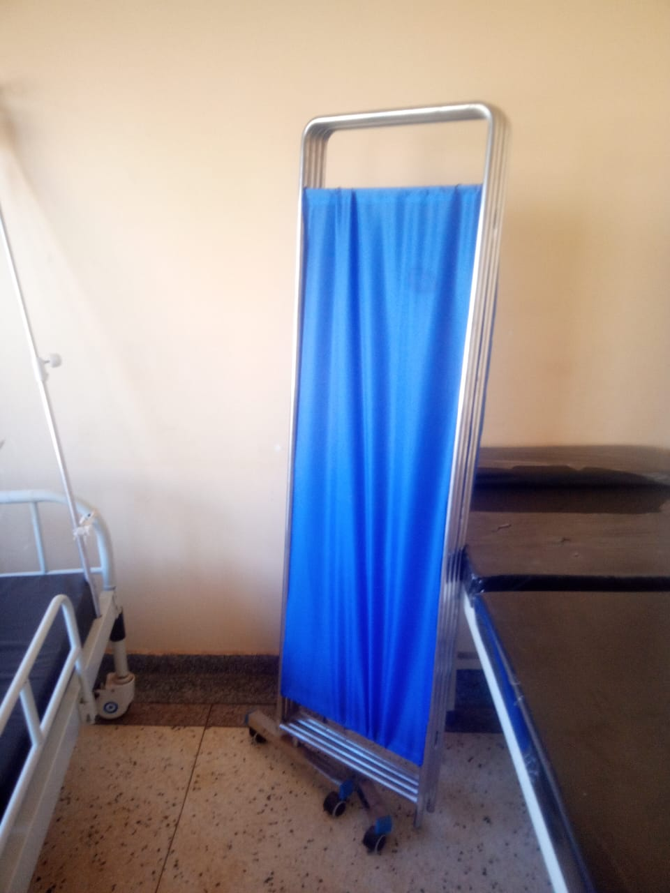
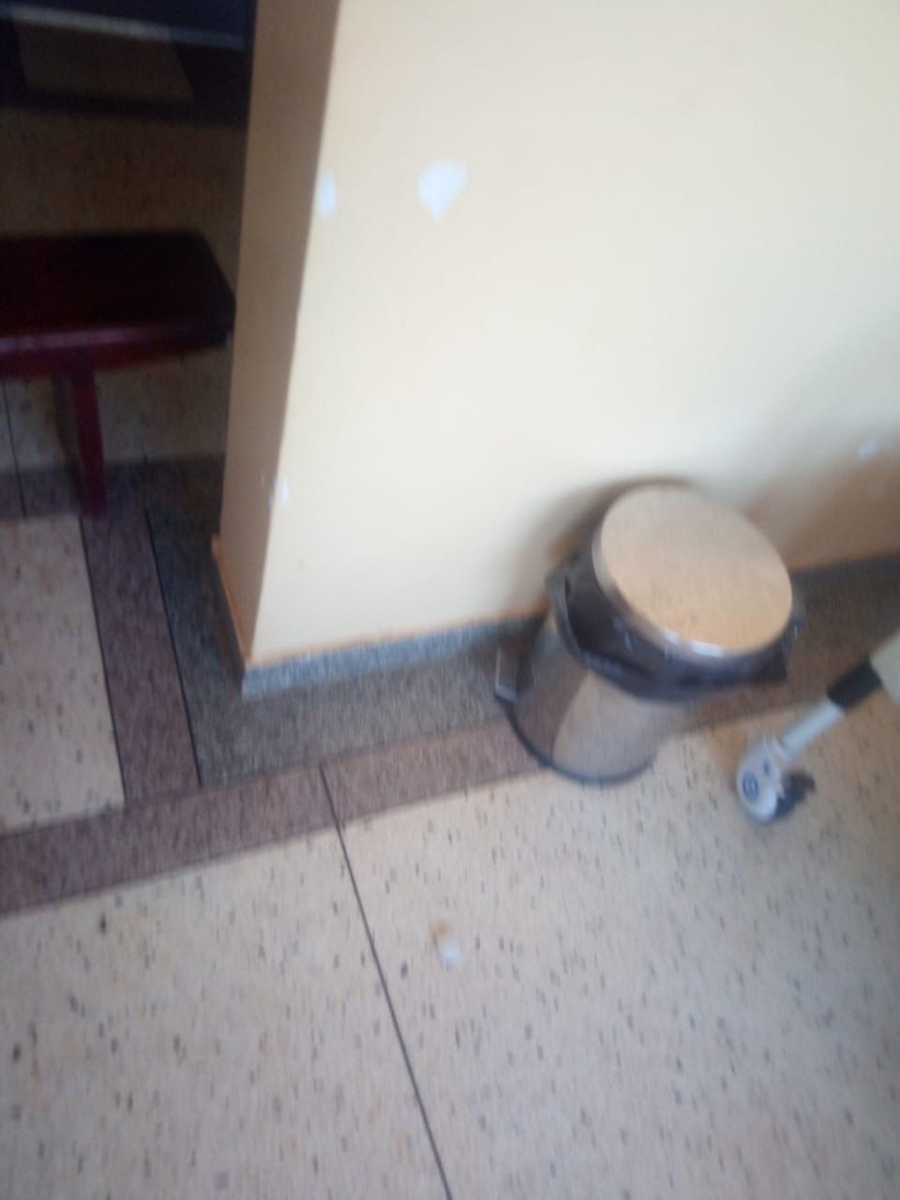
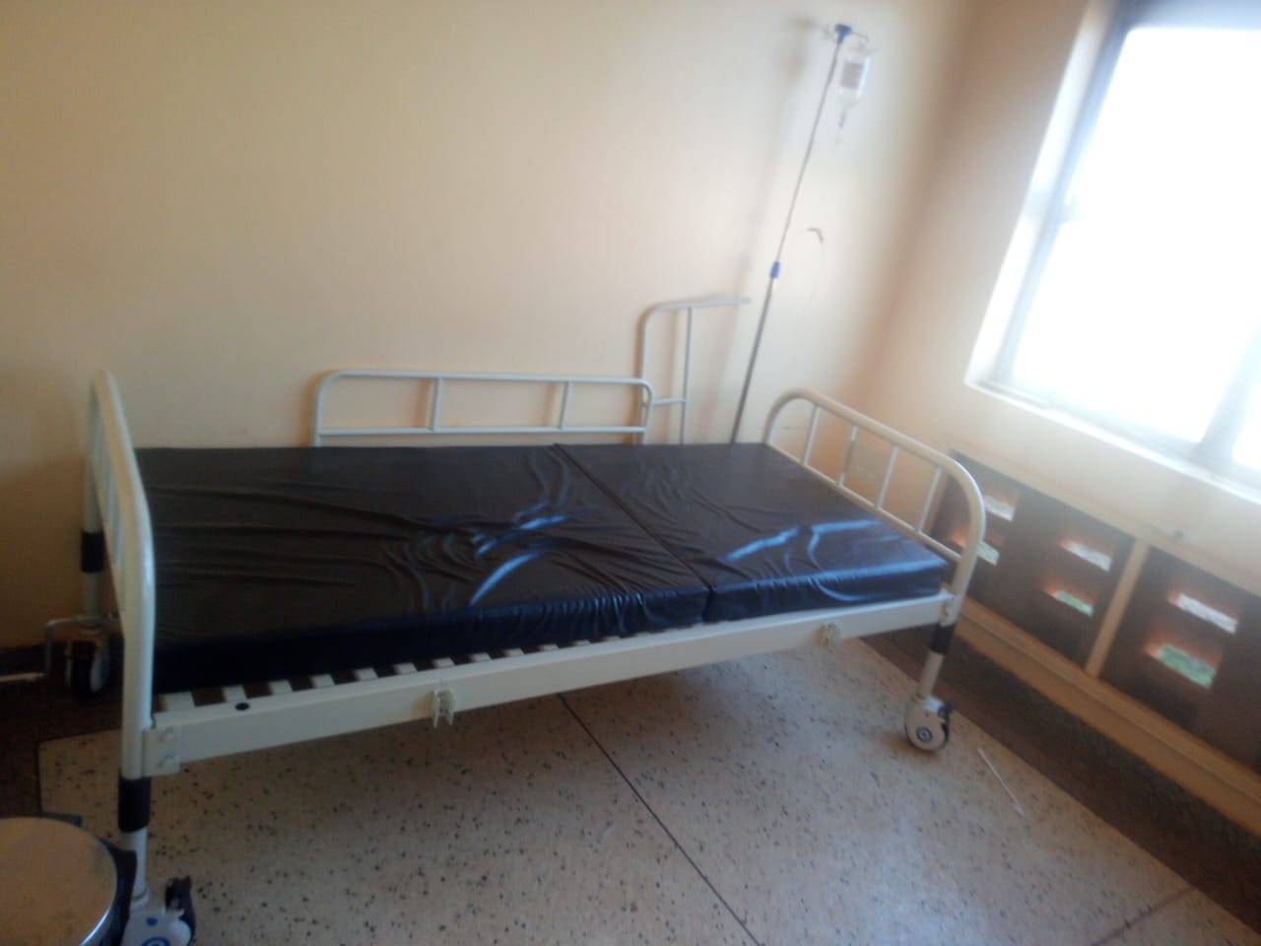
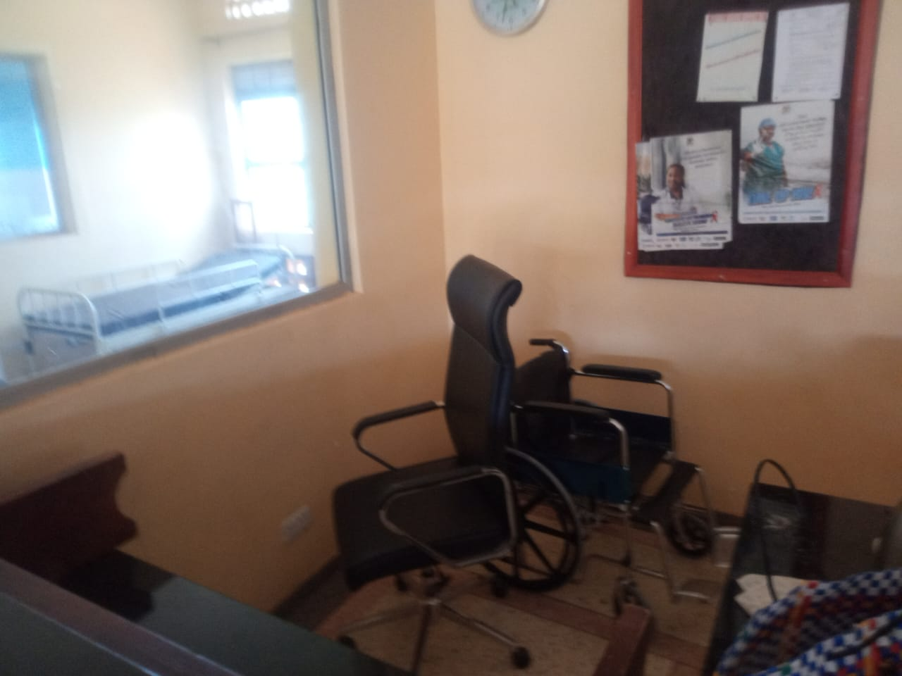
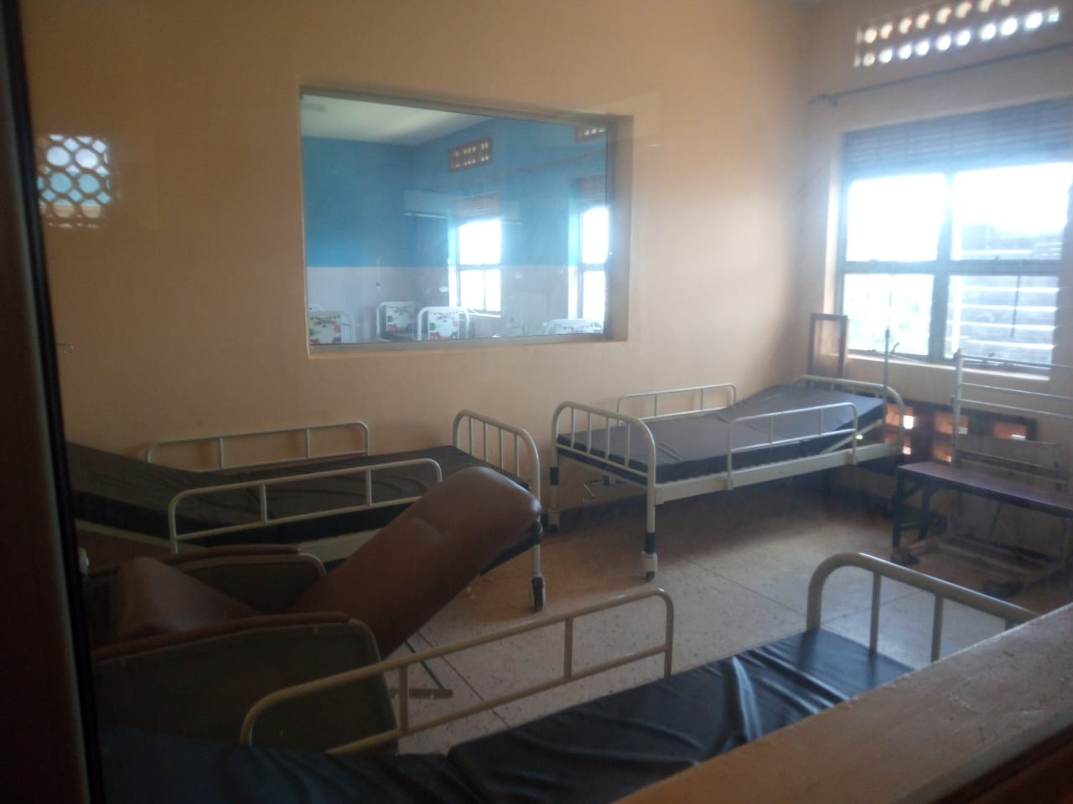

Ward Office chair

SCHOOL VERIFICATION CHECKLIST

SCHOOL INTERVIEW/DISCUSSION GUIDE

Name of school: LWEBITAKURE SEED SECONDARY SCHOOL

1a | Does the Facility have a record of all assets provided under UgIFT.  (Obtain a record and verify if it has the costs and numbers supplied | Yes
1b | If Not ask how many were supplied and when.

2 | How does this facility Maintain (repair/service/replace) the assets provided under Ugift

They get funds

3 | Does the facility take regular record about functionality/ or breakdown of the assets provided?  Nonfunctional/ working, and reasons for non-functionality. | Yes

4 | How has the UgIFT support helped in service delivery in the area, any issues, challenges and any recommendations for better program implementation.

Challenges
Buildings are so small for the students
Staff teachers are not enough
Equipments are not enough

PROCEED TO VERIFICATION AFTER THIS DISCUSSION

SCHOOL FURNITURE
(School Desks, Office chairs, Laboratory stools, Book shelves)

Name of LG: SSEMBABULE DISTRICT Name of SCHOOL: LWEBITAKURE SEED SECONDARY SCHOOL

Equipment/ Item | Department | Asset Number | Item  Description | Life in Months | Tag Number ( engrave no.) | Date Of Pur | Date Placed In Service | Recoverable cost | Cost | Acc Dep Cost | Net Book Value | Ytd Deprn | Equipment status | Remarks
Desks | Education | 120 | Received 120 wooden |  | Not  engraved |  |  |  |  |  |  |  | Good | Functional
Tables | Education | 52 | They received 52 wooden |  | Not  engraved |  |  |  |  |  |  |  | Good | Functional
Stools | Education | 100 | They received 100 wooden seats with metallic stands |  | Not  engraved |  |  |  |  |  |  |  | Good | Functional

ICT ITEMS TO VERIFY
(Desktop Computer, Server Processor, Network Switch 24 Port, Multipurpose Printer, UPS, Projector, Air Conditioners, Server, CCTV Camera)

Name of LG SSEMBABULE DISTRICT Name of SCHOOL: LWEBITAKURE SEED SECONDARY SCHOOL

Equipment/ Item | Department | Asset Number | Item  Description | Life in Months | Tag Number ( engrave no.) | Date Of Pur | Date Placed In Service | Recoverable cost | Cost | Acc Dep Cost | Net Book Value | Ytd Deprn | Equipment status | Remarks
Computers | Education | 28 | They received  28 black in  Colour with a  Full set |  |  |  |  |  |  |  |  |  | Good | Functional
Printer | Education | 1 | Received 1  White in colour |  |  |  |  |  |  |  |  |  | Good | Functional
Projectors | Education | 1 | Received 1  But still packed |  |  |  |  |  |  |  |  |  | Good | Functional
Gas cylinders | Education | 2 | Received 2  But not verified |  |  |  |  |  |  |  |  |  | Good | Functional
CCTV camera | Education | 1 | Received 1 but  Not verified

BUILDINGS TO VERIFY
(Non- Residential and Residential, Kitchen, Toilets/Pit latrine Water tanks, Fences etc.)

Name of LG SSEMBABULE DISTRICT Name of SCHOOL: LWEBITAKURE SEED SECONDARY SCHOOL

Equipment/ Item | Department | Asset Number | Item  Description | Life in Months | Tag Number ( engrave no.) | Date Of Pur | Date Placed In Service | Recoverable cost | Cost | Acc Dep Cost | Net Book Value | Ytd Deprn | Equipment status | Remarks
Class block | Education | 3 | They received 3 blocks each with 2 classrooms |  |  |  |  |  |  |  |  |  | Good | Functional
Toilets | Education | 5 | Received 5 blocks with 2 rooms |  |  |  |  |  |  |  |  |  | Good | Functional
Tanks | Education | 2 | Received 2 black and plastic |  |  |  |  |  |  |  |  |  | Good | Functional
ICT/Library | Education | 1 | They received 1 block shared by ICT and Library |  |  |  |  |  |  |  |  |  | Good | Functional
Science lab | Education | 1 | 1 block |  |  |  |  |  |  |  |  |  | Good | Functional
Main hall | Education | 1 | 1 block |  |  |  |  |  |  |  |  |  | Good | Functional
Staff quarter | Education | 1 | 1 block |  |  |  |  |  |  |  |  |  | Good | Functional

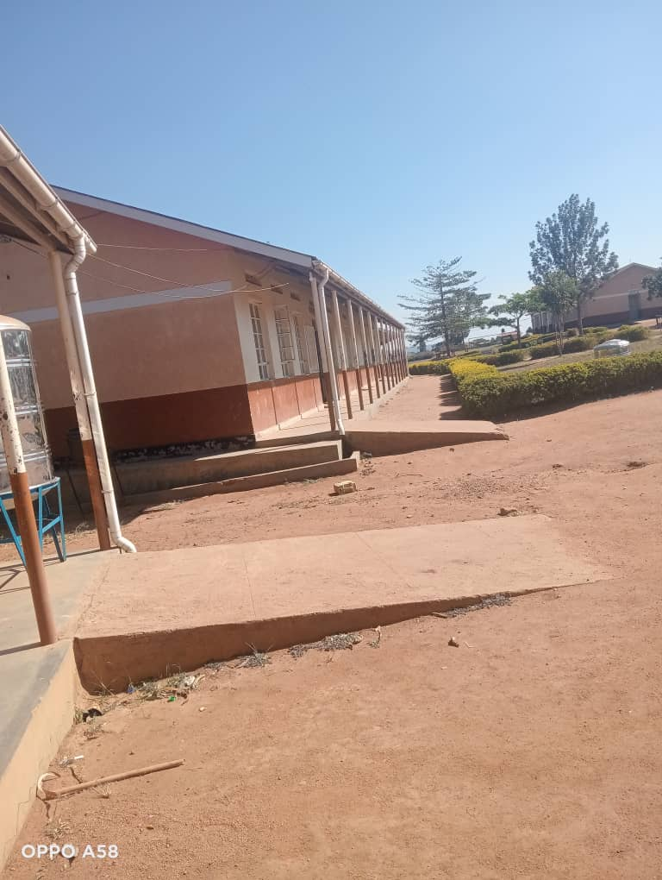
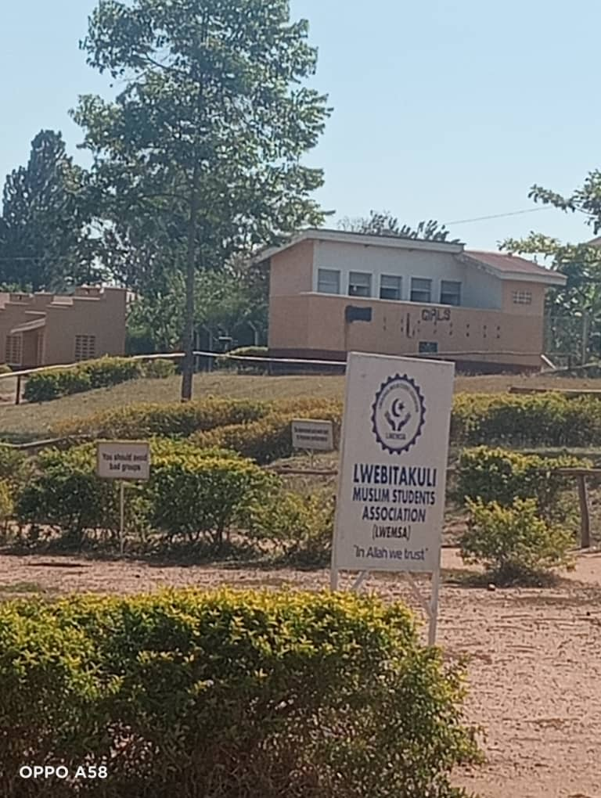
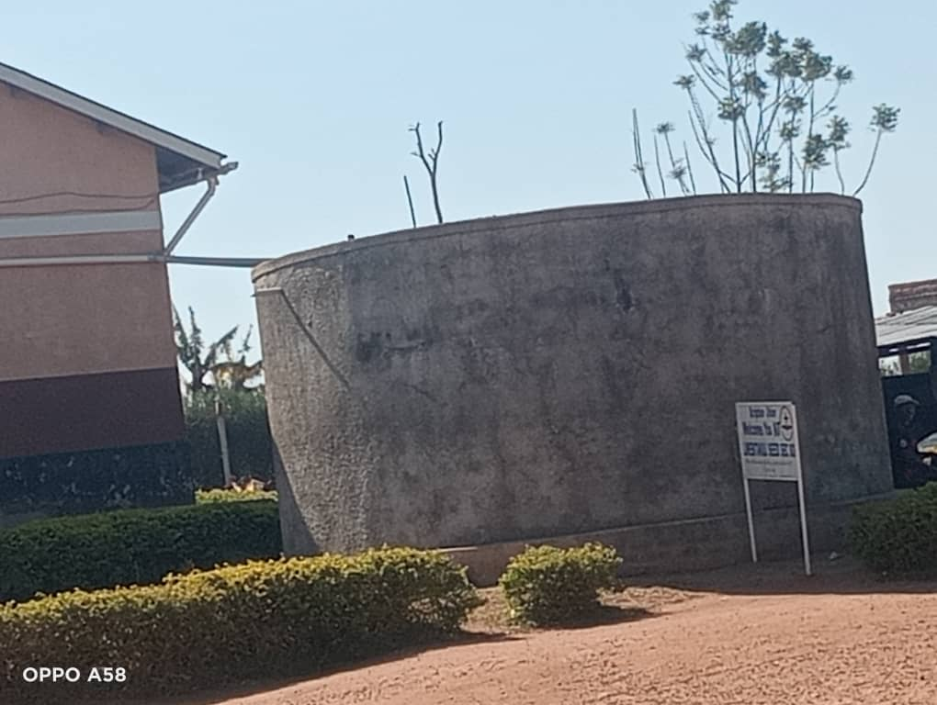
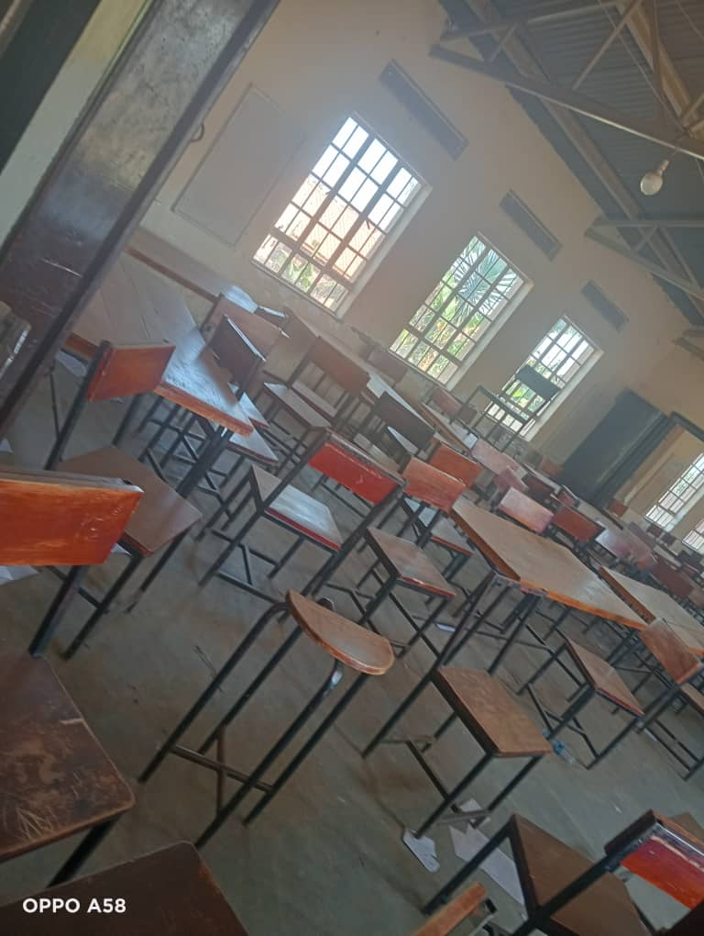
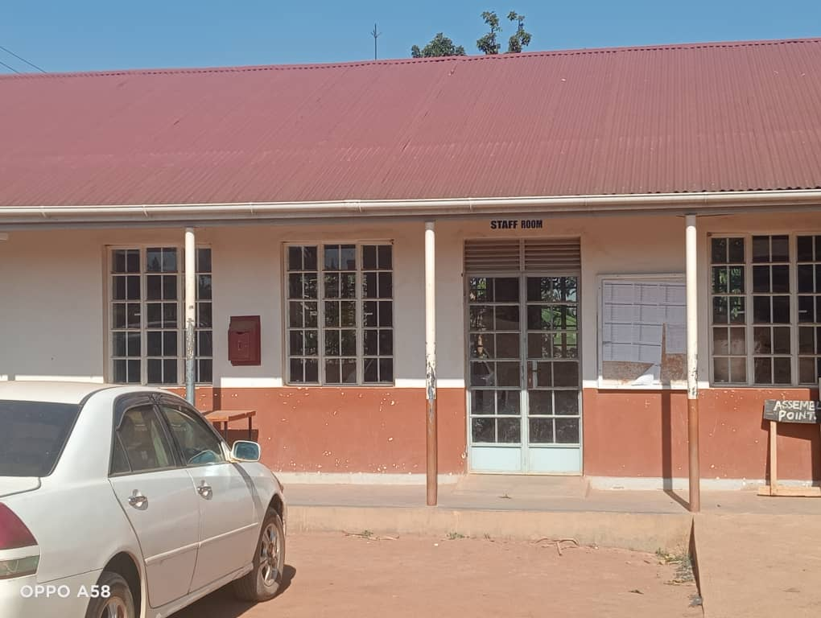
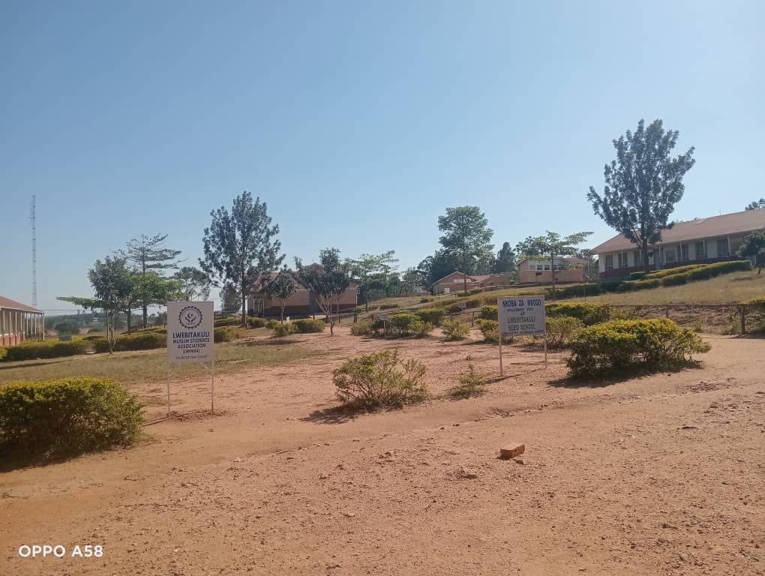
Compound Administration block Main hall Tank

Sign post Class block

